

Lab 2

[Click here to Register Attendance](https://goo.gl/forms/J9WP2kj83JC1mKYU2)

|  |  |
| --- | --- |
| Name | Teresa Shumba |
| Date | 30/04/2024 |
| Student No | S00249302 |
| Student Email | S00249302@atu.ie |

### **Project Ideas**

### **GitHub Desktop**

1. Go to <http://github.com> and sign in
2. Install GitHub Desktop from here: <https://desktop.github.com/> and sign-in
3. Using GitHub Desktop, Clone the FirstRepo repository from your GitHub account and screenshot it here   
   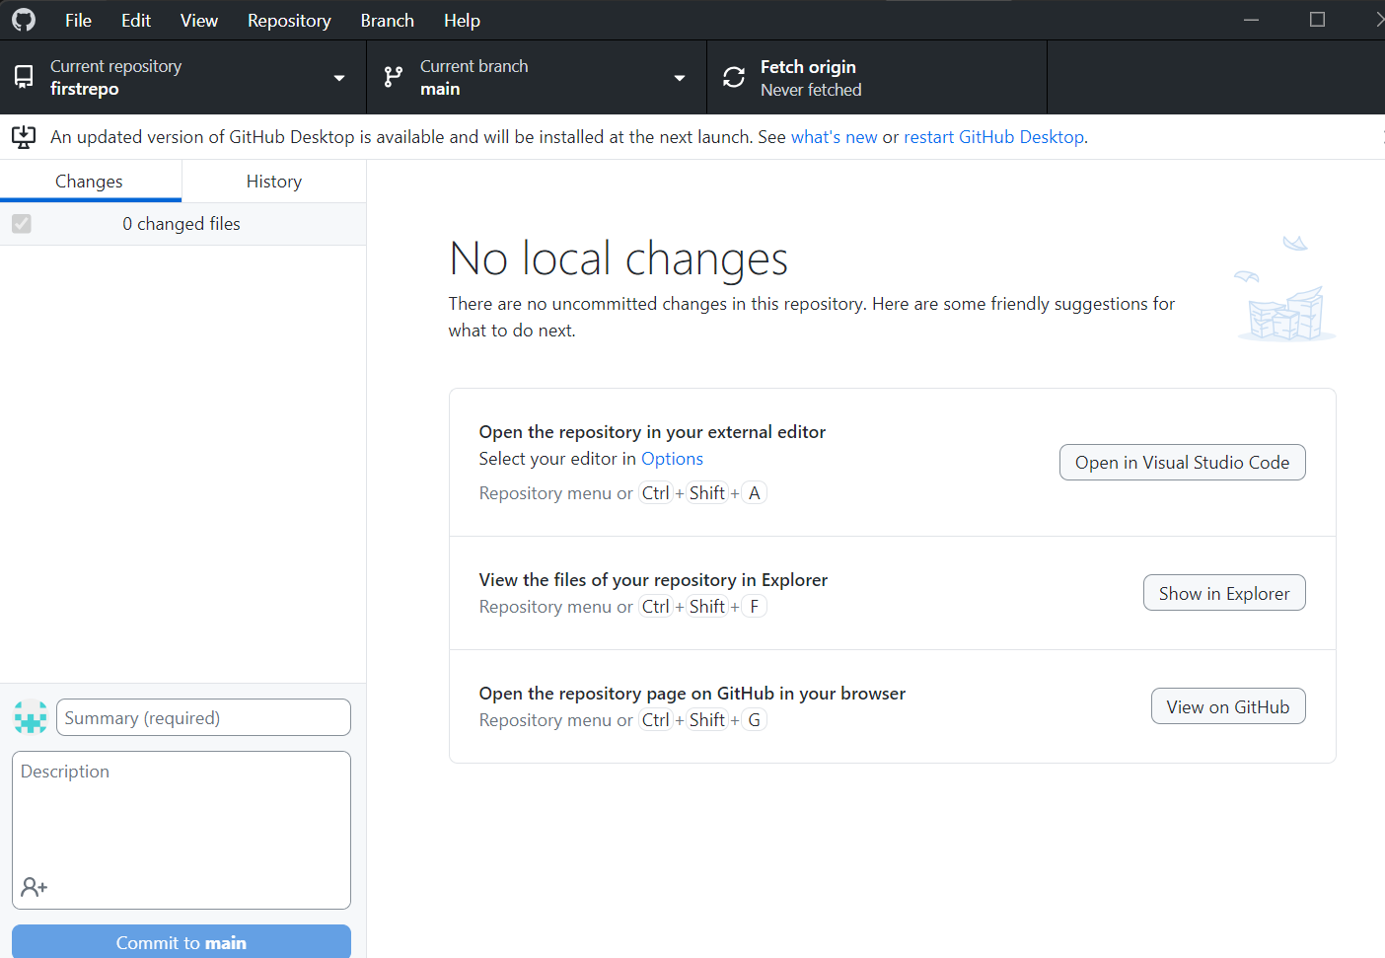
4. **Using Github Desktop**, create a repository called **secondrepo**
5. In your secondrepo folder add a file and save it, then **commit** the change and **push** it to your GitHub account
6. **Using Github Desktop**, create a repository called **secondrepo**
7. In your secondrepo folder add a file and save it, then **commit** the change and **push** it to your GitHub account
8. Paste a screenshot below (replace mine) of your pushed **secondrepo** repository on GitHub.com

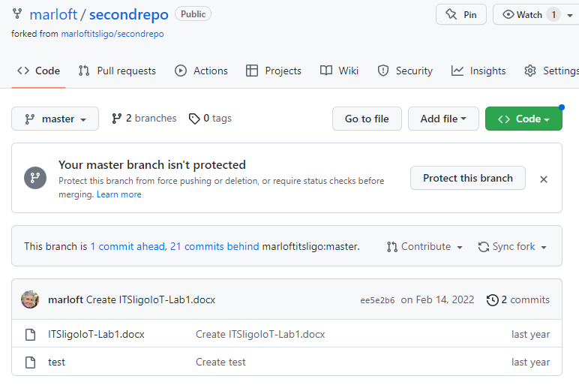

### **Arduino IDE & Coding Basics**

1. Find the Analog Read Serial sketch on the Arduino Website and get familiar with it:

[Analog Read Serial](https://docs.arduino.cc/built-in-examples/basics/AnalogReadSerial/)

1. Open the Potentiometer sketch on the Wokwi emulator here: <https://bit.ly/3UtAg25>   
   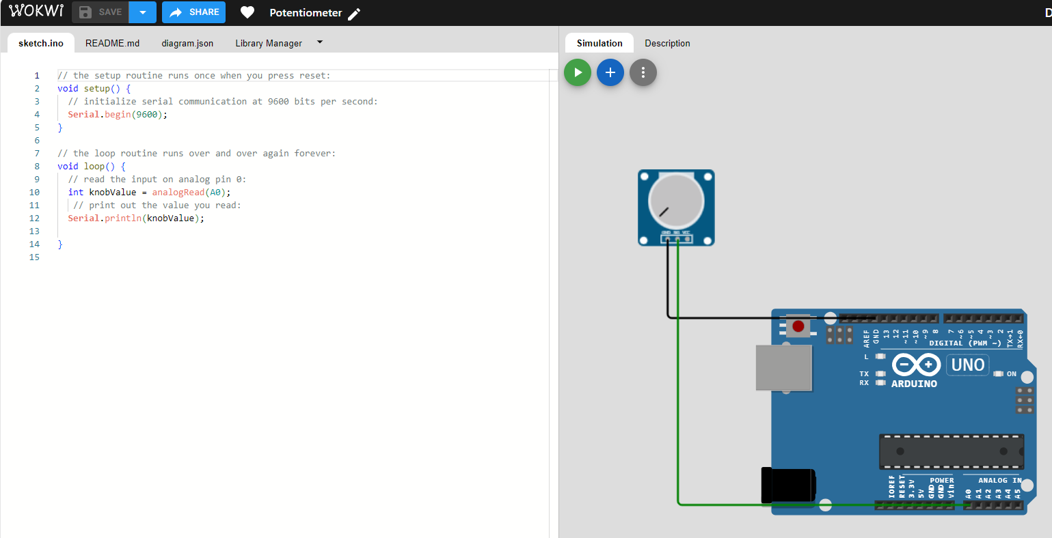
2. Run the sketch and note the values changing when you turn the Potentiometer  
   Soon, we’ll be trying this using the Grove Kit and Arduino: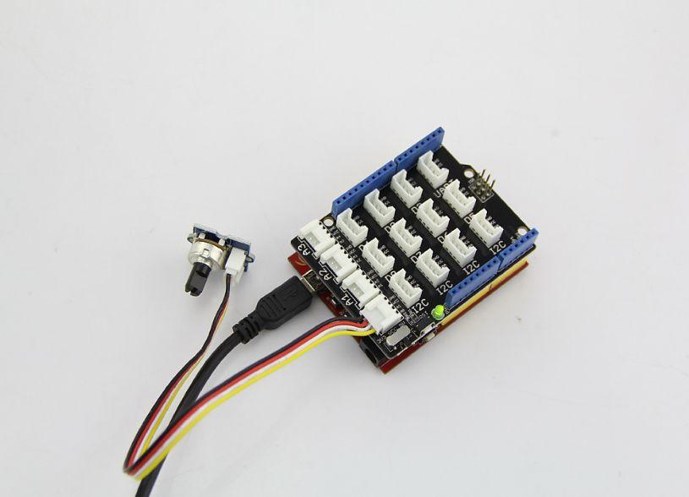
3. Add an LED to the sketch
4. Wire one side of the LED to a GND (Ground) port on the board
5. Wire the other side of the LED to Digital Port 2
6. Write code in the Loop() method to detect values of over 400 coming from the Potentiometer and in response to this level, light up the LED
7. Add a screenshot of your code changes here:
8. Add the modified code to your Github Account and provide the link here:

|  |
| --- |
|  |

1. **Upload your Lab to Moodle!**